What is FERPA?
The Family Educational Rights and Privacy Act (FERPA) is a Federal law that protects personally identifiable information (PII) in students’ education records from unauthorized disclosure. It affords parents the right to have access to their children's education records, the right to seek to have the records amended, and the right for parents and eligible students to have some control over the disclosure of PII from education records.
FERPA includes provisions allowing students’ PII from education records to be disclosed without the prior written consent of parents, if the disclosure meets the criteria for one of the permitted consent exceptions.
The school official exception allows educational agencies to share PII from education records without consent with contractors, consultants, volunteers, or other parties to whom an agency or institution has outsourced institutional services or functions, as long as certain additional requirements are met.
The FERPA statute is codified at 20 U.S.C. § 1232g, and the FERPA regulations are found at 34 CFR Part 99.

What are my responsibilities under [Name of State Statute]?

[Insert information about state requirements.]

Who can I contact for more information?

[Insert name of appropriate contact.]
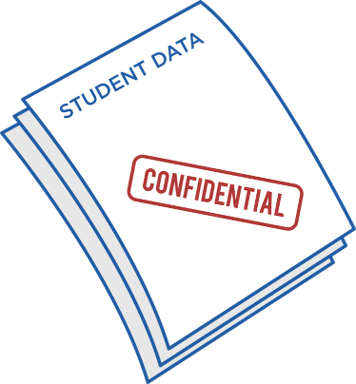


Acknowledgement of Volunteer Responsibilities under the Family Educational Rights and Privacy Act (FERPA)

[and]

[Name of State Statute]

This document is intended for Local Education Agencies (LEAs) and schools to give to their volunteers to inform them about their responsibilities to protect students’ personally identifiable information from education records acquired under FERPA’s school official exception. For more information about FERPA, please visit https://studentprivacy.ed.gov.

Introduction
You have volunteered for [name of school/district] to perform services that require you to access and use personally identifiable information (PII) from students’ education records. Your access and use of the PII is governed by the Family Educational Rights and Privacy Act (FERPA).
FERPA requires the school or school district to maintain “direct control” over your use and maintenance of students’ education records and to use reasonable methods to ensure that you obtain access to only those education records in which you have an educational interest.
If you have any questions about information in this document, they should be directed to [point of contact for your school or school district].



What should I do to protect student PII from education records under FERPA?
It’s important that you take the following steps to protect student privacy:

- Do not disclose the PII to another party (except back to the School or District). The PII must not be shared with unauthorized users, and it must be protected from inadvertent disclosure due to careless handling.

- Do not use the PII for other purposes. The PII has been provided only for you to perform the volunteer service for which the school provided you the information. It should not be used for other purposes.

- Do not keep the PII after you complete your volunteer service. Destroy or return the PII to the school or district after completion of the service that you provided.

The undersigned acknowledges that he or she has read, understands, and will uphold all responsibilities as outlined in Acknowledgement of Volunteer Responsibilities under FERPA.

_______________________________
(Print name)

_______________________________
(Name of school or school district)

_______________________________
(Signature)

_______________________________
(Date)

